**­­­**

Class 7

**Lecture 18**

**HTML**

**HTML table**

**HTML**



**Lab Objectives:**

* Creating Table.
* Adding Table Heading.
* Adding Table Border.

**HTML Table**

The HTML tables allow web authors to arrange data like text, images, links, other tables, etc. into rows and columns of cells.

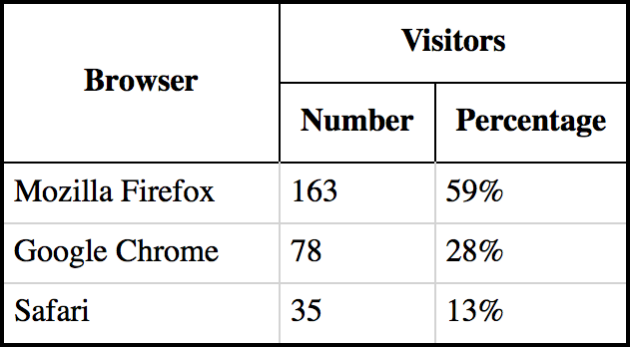

The HTML tables are created using the <table> tag in which the <tr> tag is used to create table rows and <td> tag is used to create data cells.

<!DOCTYPE html>

<html>

**<body>**

<h2>Basic HTML Table</h2>

<table style="width:60%">

**<tr>**

<th>Firstname</th>

<th>Lastname</th>

<th>Age</th>

**</tr>**

**<tr>**

<td>Jill</td>

<td>Smith</td>

<td>50</td>

**</tr>**

**<tr>**

<td>Sahid</td>

<td>Khan</td>

<td>33</td>

**</tr>**

**<tr>**

<td>Jannatun</td>

<td>Khatun</td>

<td>27</td>

**</tr>**

**<tr>**

<td>Babu</td>

<td>Rahman</td>

<td>60</td>

**</tr>**

**<tr>**

<td>Eve</td>

<td>Jackson</td>

<td>94</td>

**</tr>**

</table>

**</body**

</html>

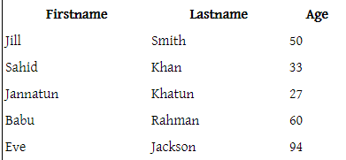

This following table will produce for previous HTML code.

**Table heading**

Table heading can be defined using <th> tag. This tag will be put to replace <td> tag, which is used to represent actual data cell. Normally you will put your top row as table heading as shown below, otherwise you can use <th> element in any row. Headings, which are defined in <th> tag are centered and bold by default.

<!DOCTYPE html>

<html>

**<head>**

<title>HTML Table Header</title>

**</head>**

**<body>**

<table width="40%">

<tr>

<th>Name</th>

<th>Salary</th>

</tr>

<tr>

<td>Ramesh Raman</td>

<td>5000</td>

</tr>

<tr>

<td>Shabbir Hussein</td>

<td>7000</td>

</tr>

</table>

**</body>**

</html>

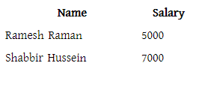

**Adding Border**

